

**MSc in Business Analytics**

**BS1813: Retail and Marketing Analytics**

**Dr. Sismeiro, Catarina**

**Group Assignment 1**

*Submitted by* ***Group 3****:*

Andrea Iglesias Villegas - 1266828

Cecilia Cheung - 650665

David de Picciotto – 1292793

Christina Lefkothea Tatli - 1231953

Virat Bhandari - 1294287

Mei Sheng -

*on March 2nd, 2017*

Project’s Objective

The aim of this project is to analyse and compare the own- and cross-price elasticities of four different crackers products with the underlying goal of understanding the market and its competitive structure as well as clout and vulnerability.

Weekly data for prices, volumes, other promotional information and additional variables is available for each cracker, ranging from November 2014 until October 2016. The data has been sourced from the Italian market.

Data Preparation

In order to properly analyse the data, we clean it and made the appropriate transformations for the price elasticities analysis. To this extent, we first computed the unit price by dividing the value (price) by the volume for each cracker. Then, we executed three different manipulations with different objectives. First, we aimed to have a look at the relationship between price and quantity for each cracker and be able to formulate initial hypotheses for this interaction. In this respect, we created a data frame with unit price and volume for each cracker. Then, we normalise the data in our data frame and change the date types to numbers in order to build a comprehensive plot of these relationships. Secondly, the objective is to observe the relative fluctuations of each cracker’s price over the weeks in order assess the crackers’ different product categories and pricing their respective strategies. Hence, we melted the calculated unit price of each cracker into a single data frame with the goal to build a plot. Again, note that the dates in the column *Weeks* are modified to numbers in order to facilitate the graph’s visualisation. Thirdly and most importantly, we aimed to create a single data frame including all the respective crackers’ variables from the different sheets of the provided dataset. To this extent, we added next to each variable its respective cracker number and finally bound all the cracker data together in order to form a unique data frame. Again, note that the dates in the column *Weeks* are modified to numbers.

Initial Data Description and Hypothesis

* Price and Quantity of each Cracker

Common assumption regarding price and demand is that these two variables are negatively correlated: When the price for a certain product rises, its demand (or quantity) falls. In this context, theory suggests that consumers would orient themselves to a substitute product, i.e. another cracker in this assignment. To assess the data at hand, we first take a look at the weekly values (prices) and volumes across products, to verify that the initial assumption made about the relationship between price and demand holds.

Following, graphs for each product’s prices and volumes are presented over this 2-year period. Note that the data has been normalised in order to compare the unit price with the respective volume of crackers.

Overall, the hypothesis across the four graphs holds. We can see that for the most part of the assessed time period, prices and volumes are inversely proportional. Furthermore, we observe that there is little to no lag in their relationships. *(Interestingly, we note that across the four graphs volume during Christmas period drops significantly, that is around week 9 and week 60. This suggests that consumers substitute their crackers consumption for more luxurious goods as Christmas approaches.)*

* Relative Crackers’ Prices

We observe that prices fluctuates in a range of roughly 2.5 to 7.5 Euros. On their relative values, it is clear that crackers 2 is considerably cheaper than its counter products, while cracker 4 is slightly more expensive than crackers 3 and 5. Based on these observations, the following initial assumptions can be made. First, we can assume that cracker 4 is the higher-end product while cracker 2 a basic one. Cracker 3 and 5 are the middle class products. Secondly, cracker 4 can be expected to be the most sensitive to price fluctuations, since it is the most expensive good out of the four products and can be considered as more of a ‘luxury’ good in comparison. Its price fluctuations support this hypothesis. Secondly, cracker 2 can be expected to be the most after-sought product given both the type and relative cheap price of the product, particularly when other products experience price increases. Looking at cracker 3 and 5, we can expect that the competition between these two products is fierce as they seem to lie in the same category, i.e. the middle class. Based on this, we can assume that they are substitutes of each other; when there is a price increase for one product, consumers might switch to purchase the other. Finally, lower prices of crackers4 could potentially affect demand of crackers3 and crackers5, especially if the price is low enough to be within the price range of crackers3/crackers5, as customers may switch from buying crackers3/5 to crackers4 due to higher expected quality.

To conclude, initial hypotheses about the products’ categories and quantity changes are in line with the computed and analysed results. For example, we can confirm that crackers2 is a basic good given that it has no impact on other products when its price fluctuates. In addition, crackers2 becomes more attractive when substitutes, e.g. crackers3, crackers4 or crackers5, are more expensive. crackers4, being the expected higher-end product, has a similar (and also inverse) dynamic to crackers2. Furthermore, we can confirm that crackers3 and crackers5 compete fiercely for market shares as they play in the same middle-class league.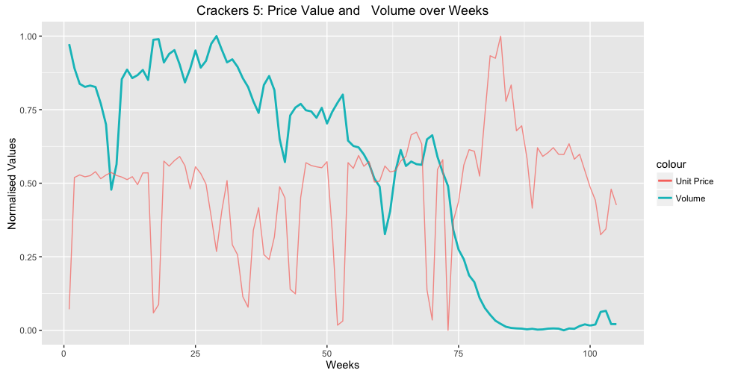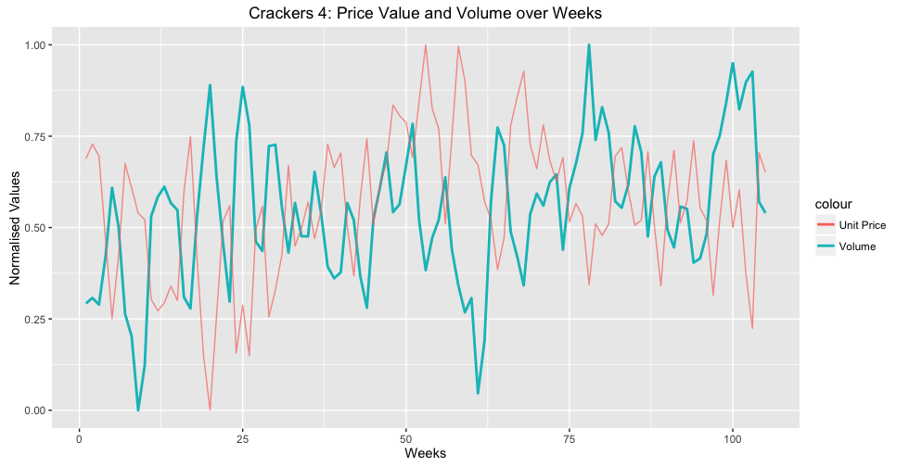

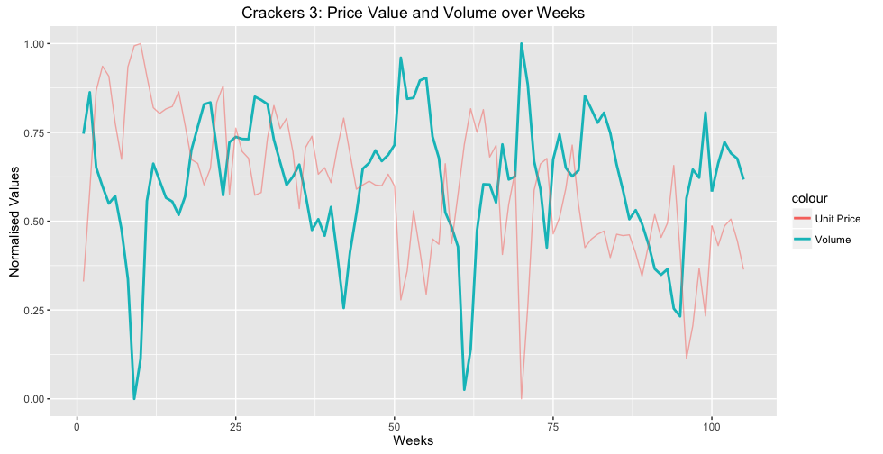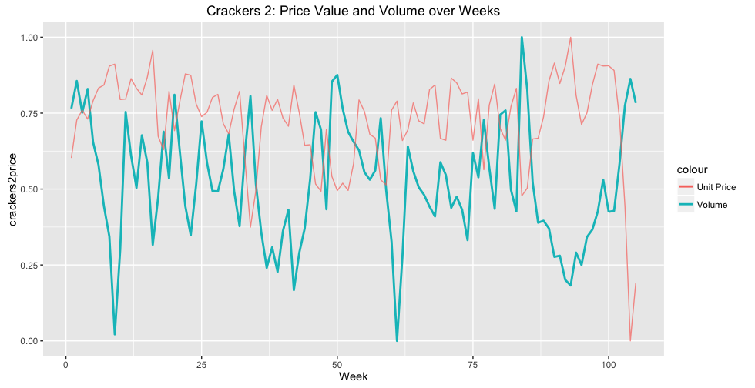

**DISREGARD; KEEPING THIS FOR DISCUSSION**

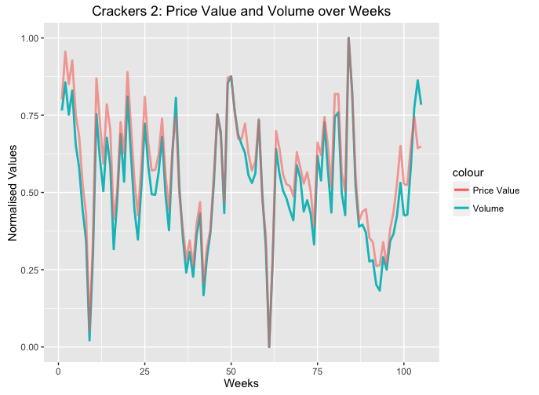

* move in parallel
* no lag

